## Project Design Phase-II

**Data Flow Diagram & User Stories**

|  |  |
| --- | --- |
| Date | 31 January 2025 |
| Team ID | LTVIP2025TMID60699 |
| Project Name | Sustainable Smart City Assistant Using IBM  Granite LLM |
| Maximum Marks | 4 Marks |

**Data Flow Diagrams:**

**Context-Level Overview**

At the highest level, the system receives **data from external APIs** (like AQI, traffic, water, and energy metrics) and interacts with the **city resident (user)**. The Smart City Assistant collects, stores, and visualizes this data, providing users with meaningful information.

**Data Flows**:

* **User → System**: Interacts via chat, dashboard, and input preferences.
* **System → External APIs**: Requests live city data.
* **System → User**: Returns processed insights, summaries, alerts, and visuals.

**Internal Functional Flow**

The system is divided into six main modules:

1. **Real-Time City Metrics**
   * Fetches and stores incoming data from APIs (air quality, traffic, etc.).
2. **Forecasting System**
   * Uses stored data to predict future trends (3–5) for each metric.
3. **Anomaly Detection**
   * Analyzes data patterns to detect and flag sudden, abnormal changes.
4. **Summarizer**
   * Simplifies weekly data into an understandable report format for the user.
5. **Chat Assistant**
   * Accepts natural language questions from the user and provides intelligent answers based on stored data or summaries.
6. **Eco Tips & Alerts**
   * Delivers timely, personalized sustainability tips and urgent alerts based on real-time or abnormal data conditions.

**Data Stores**:

* **User Preferences**: Used by chat, alerts, and tips system to personalize the experience.
* **Live Metrics**: Used by forecasting and anomaly detection.

**User Interaction Flow**:  
City residents interact via the UI to receive:

* Dashboard updates
* Chat responses
* Eco tips
* Summarized reports
* Forecasts and alerts

**Example:** [**(Simplified)**](https://developer.ibm.com/patterns/visualize-unstructured-text/)

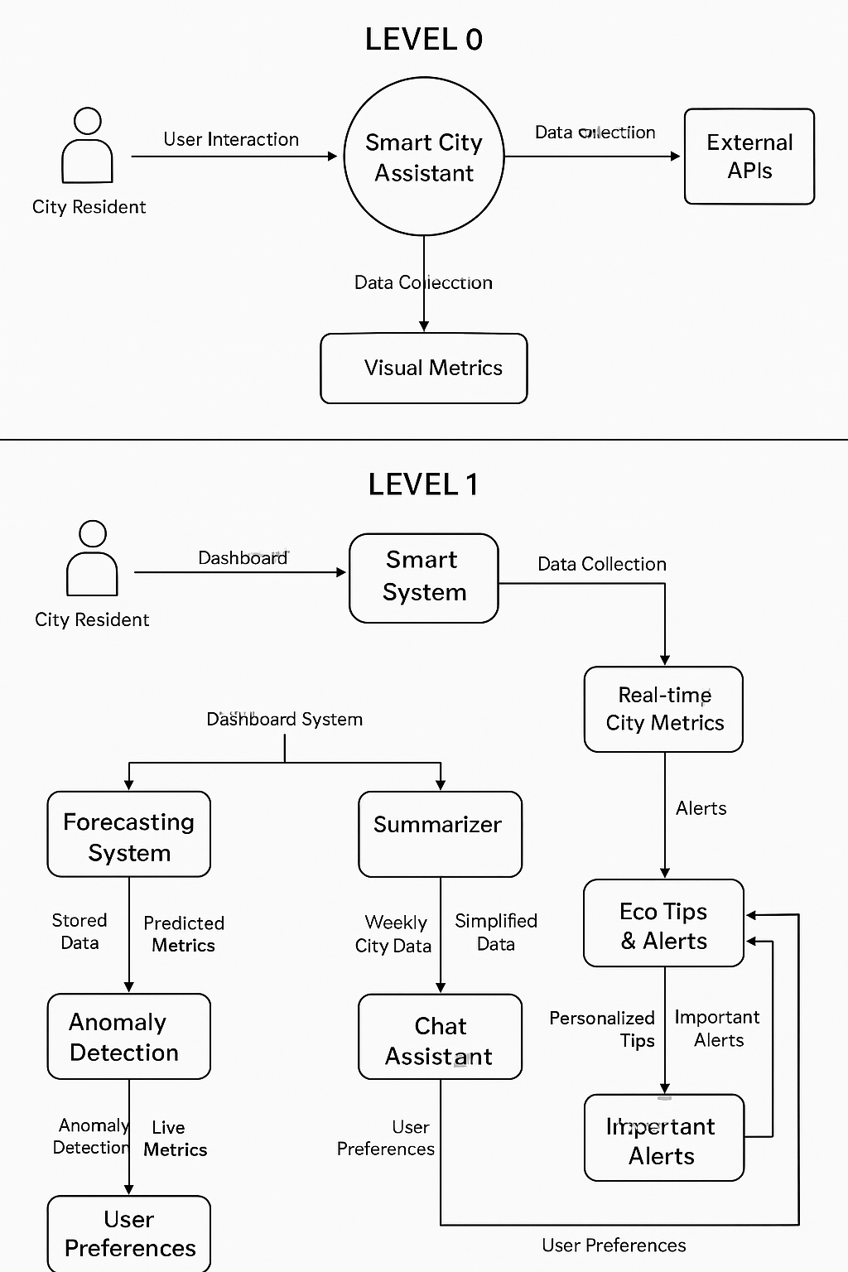

**User Stories**

Use the below template to list all the user stories for the product.

|  |  |  |  |  |  |  |
| --- | --- | --- | --- | --- | --- | --- |
| **User Type** | **Functional Requirement (Epic)** | **User Story No.** | **User Story / Task** | **Acceptance Criteria** | **Priority** | **Release** |
| **City Resident (Web)** | **Dashboard** | **USN-1** | **As a user, I can view real-time city metrics like AQI, water, traffic, energy.** | **I can see clear visuals of metrics updated regularly** | **High** | **Sprint-1** |
|  |  | **USN-2** | **As a user, I can switch between cities and themes.** | **Switching city updates all data; themes change layout without bugs** | **Medium** | **Sprint-1** |
|  | **Forecasting** | **USN-3** | **As a user, I can view short-term environmental forecasts.** | **Forecasts display for 3–5 days clearly for each metric** | **High** | **Sprint-2** |
|  | **Anomaly Detection** | **USN-4** | **As a user, I get notified when sudden changes happen in the city data.** | **App flags anomalies with a warning color/icon** | **High** | **Sprint-3** |
|  | **Smart Chat Assistant** | **USN-5** | **As a user, I can ask the assistant eco-related questions or for help navigating.** | **Chat responds accurately to city-specific or generic queries** | **Medium** | **Sprint-4** |
|  | **Summarizer** | **USN-6** | **As a user, I can see a weekly eco summary of my city.** | **Weekly summaries are generated and easy to read** | **Medium** | **Sprint-4** |
|  | **Eco Tips** | **USN-7** | **As a user, I get simple green tips based on my city conditions.** | **Tips match local metrics (e.g., if AQI is bad, recommend indoor plants)** | **Medium** | **Sprint-5** |
|  | **Alerts** | **USN-8** | **As a user, I get important alerts (like high pollution, water warnings).** | **Only critical, personalized alerts are sent** | **High** | **Sprint-5** |